Directions to Fill Circuit House Feedback Form

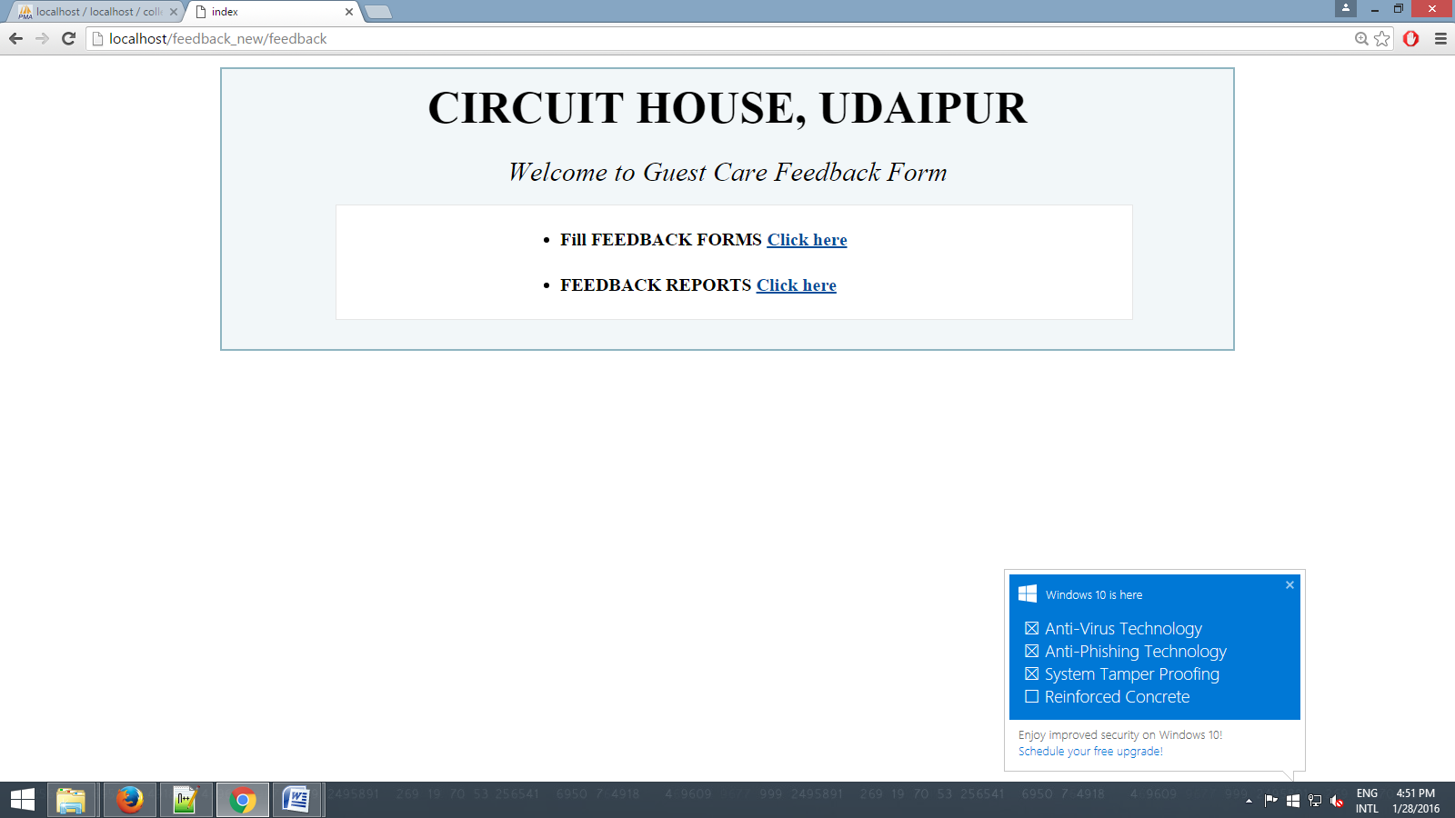

- Open browser and type www.uitudaipur.org/chouse/ (website URL) in the address bar.

- You will see the screen as given above.

- To fill Feedback Form of Circuit House, click on 1st link.

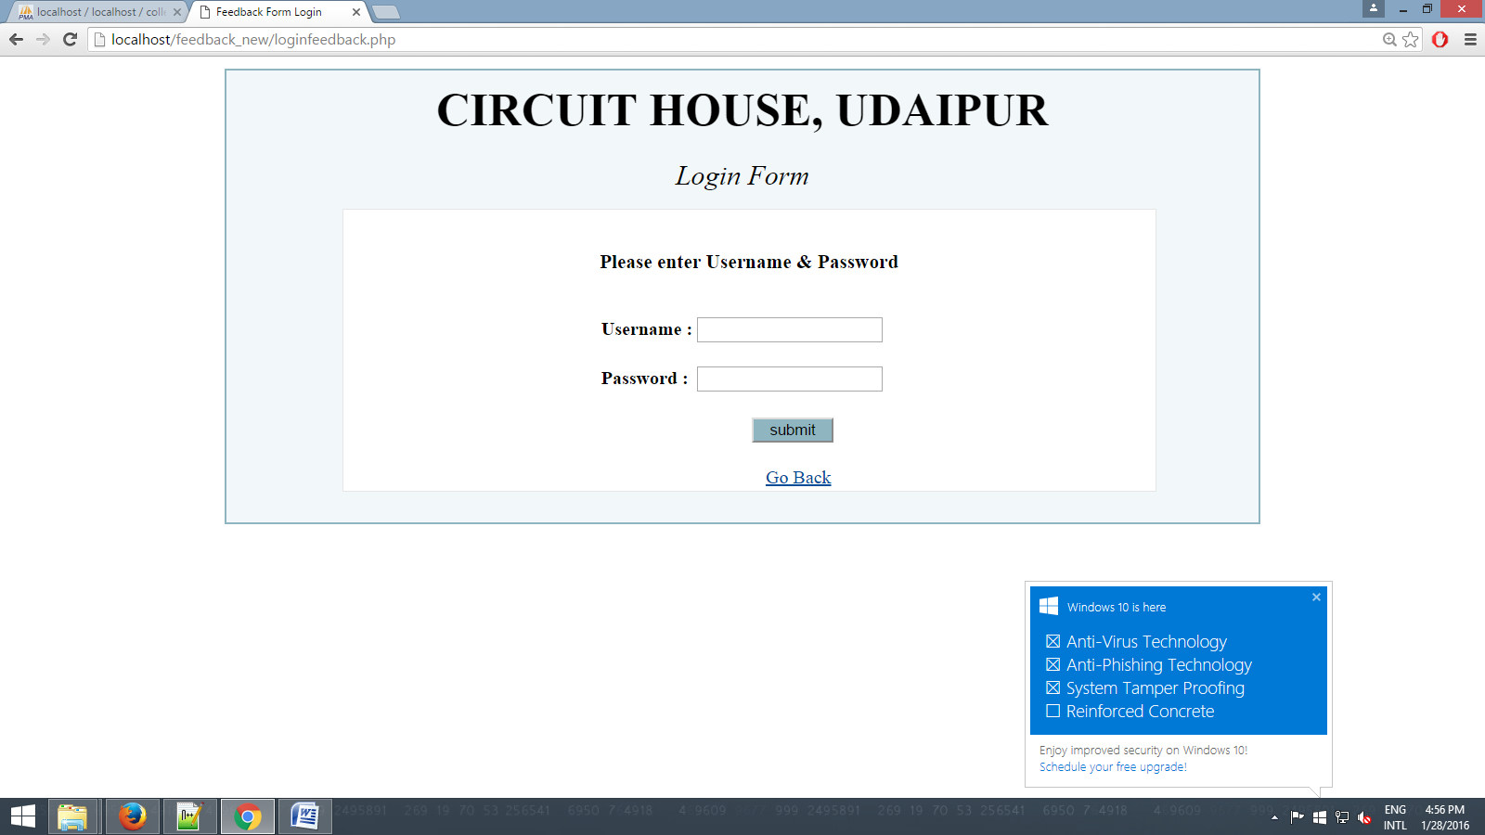

- A login form will be open, fill username & password given by NIC and submit the form.

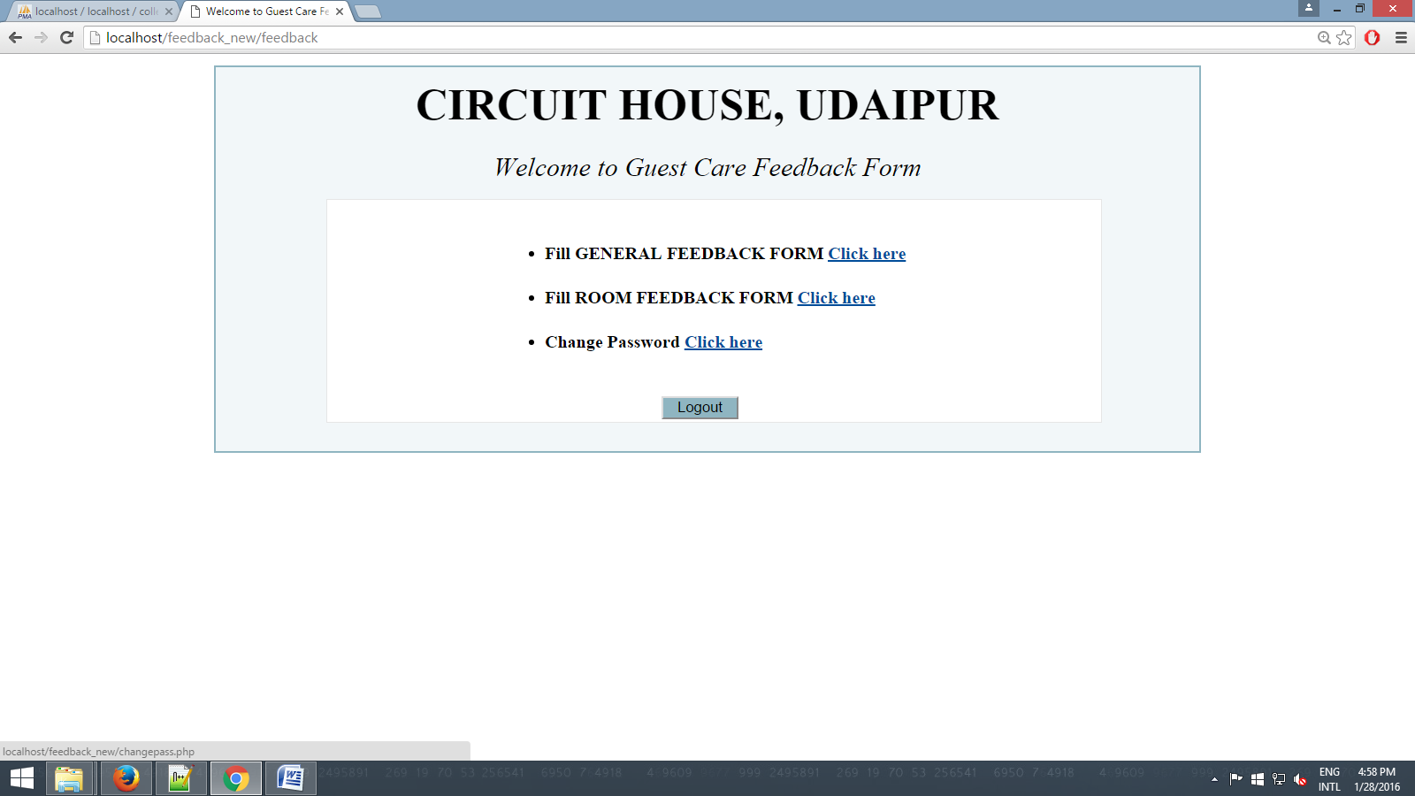

- Above page will be open, now you can change your password by clicking on 3rd link such as “Change Password”.

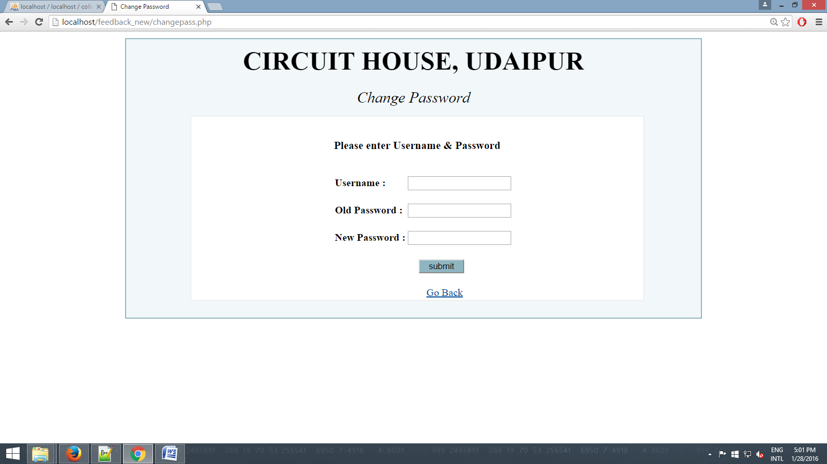

- Change Password window will be open fill current username in username section, current password in old password section and new password as per your choice in new password section.

- Click on submit button you will get message like “Password Changed Successfully.” Click OK and you will redirect to index page as given below.

- Now click on 1st link and login with username and new password, you will get page as given below.

- Click on 1st link to fill general feedback form.

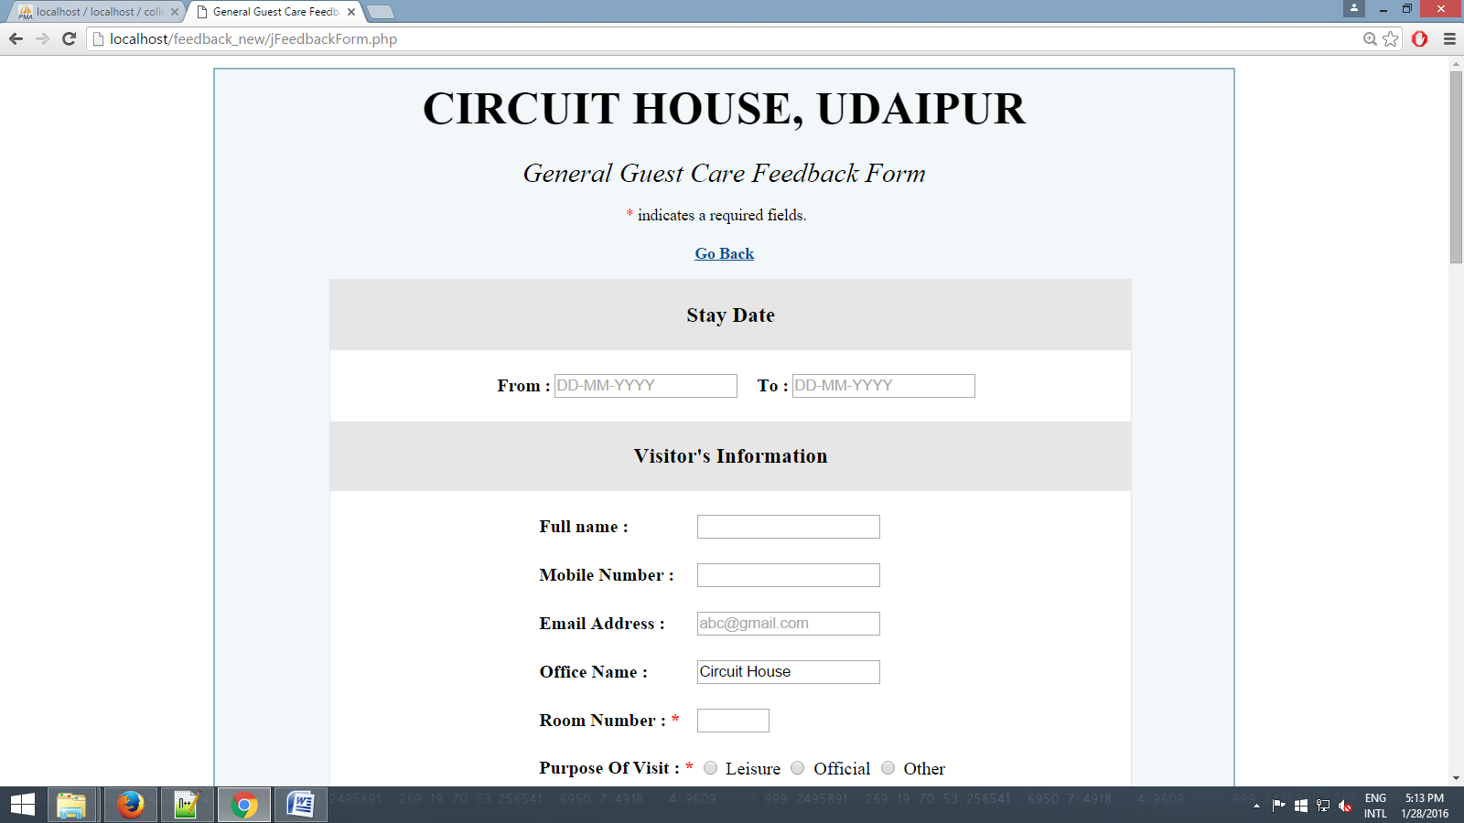

- You will get feedback form page, fill all information like from date and to date (From Date = on which date visitor Check in Circuit House, To Date = on which date visitor Checked out from Circuit House) Visitor name, mobile number, visitor’s room number and purpose of visit. Check any one radio button for given services.

- It is compulsory to check any one radio button for each service.

- Give suggestion or comment in the given box.

- Click on submit button to save your feedback, you will get message like “Thank You for Your Feedback.”

- Same procedure will be followed in the Room Feedback Form.

